TERRAFORM CHALLENGE

Start working on final Terraform Final Task.
- Create VPC
- Create Internet gateway
- Create Custom Route Table
- Create Subnet
- Associate subnet with Route Table
- Create Security Group to allow port 22.80,443
- Create a network interface with an ip in the subnet that was created in step 4
- Assign an elastic IP to the network interface created in step 7
- Create Ubuntu server and install/enable apache2

variables.tf
variable "region" {
default = "eu-north-1"
}

variable "vpc_cidr" {
default = "10.0.0.0/16"
}

variable "public_subnet_cidr" {
default = "10.0.1.0/24"
}

variable "az" {
default = "eu-north-1a"
}

variable "instance_type" {
default = "t3.micro"
}

variable "private_ip" {
default = "10.0.1.10"
}
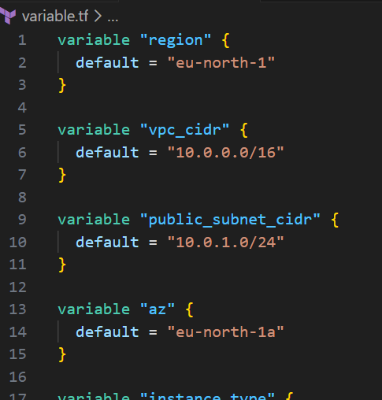

2️⃣ main.tf (Amazon Linux version)
terraform {
required_providers {
aws = {
source = "hashicorp/aws"
version = "~> 5.0"
}
}
}

provider "aws" {
region = var.region
}

############################
# 1. VPC
############################
resource "aws_vpc" "main_vpc" {
cidr_block = var.vpc_cidr
enable_dns_support = true
enable_dns_hostnames = true

tags = {
Name = "final-task-vpc"
}
}

############################
# 2. Internet Gateway
############################
resource "aws_internet_gateway" "igw" {
vpc_id = aws_vpc.main_vpc.id

tags = {
Name = "final-task-igw"
}
}

############################
# 3. Route Table
############################
resource "aws_route_table" "public_rt" {
vpc_id = aws_vpc.main_vpc.id

route {
cidr_block = "0.0.0.0/0"
gateway_id = aws_internet_gateway.igw.id
}

tags = {
Name = "final-task-public-rt"
}
}

############################
# 4. Public Subnet
############################
resource "aws_subnet" "public_subnet" {
vpc_id = aws_vpc.main_vpc.id
cidr_block = var.public_subnet_cidr
availability_zone = var.az
map_public_ip_on_launch = false

tags = {
Name = "final-task-public-subnet"
}
}

############################
# 5. Subnet Association
############################
resource "aws_route_table_association" "public_assoc" {
subnet_id = aws_subnet.public_subnet.id
route_table_id = aws_route_table.public_rt.id
}

############################
# 6. Security Group (22, 80, 443)
############################
resource "aws_security_group" "web_sg" {
name = "final-task-web-sg"
description = "Allow SSH, HTTP, HTTPS"
vpc_id = aws_vpc.main_vpc.id

ingress {
from_port = 22
to_port = 22
protocol = "tcp"
cidr_blocks = ["0.0.0.0/0"]
}

ingress {
from_port = 80
to_port = 80
protocol = "tcp"
cidr_blocks = ["0.0.0.0/0"]
}

ingress {
from_port = 443
to_port = 443
protocol = "tcp"
cidr_blocks = ["0.0.0.0/0"]
}

egress {
from_port = 0
to_port = 0
protocol = "-1"
cidr_blocks = ["0.0.0.0/0"]
}

tags = {
Name = "final-task-web-sg"
}
}

############################
# 7. Network Interface (ENI)
############################
resource "aws_network_interface" "web_eni" {
subnet_id = aws_subnet.public_subnet.id
private_ips = [var.private_ip]
security_groups = [aws_security_group.web_sg.id]

tags = {
Name = "final-task-web-eni"
}
}

############################
# 8. Elastic IP for ENI
############################
resource "aws_eip" "web_eip" {
vpc = true
network_interface = aws_network_interface.web_eni.id

depends_on = [aws_internet_gateway.igw]

tags = {
Name = "final-task-web-eip"
}
}

############################
# 9. Amazon Linux EC2 + Apache
############################

# Get latest Amazon Linux 2 AMI
data "aws_ami" "amazon_linux" {
most_recent = true

owners = ["amazon"]

filter {
name = "name"
values = ["amzn2-ami-hvm-*-x86_64-gp2"]
}
}

resource "aws_instance" "web_server" {
ami = data.aws_ami.amazon_linux.id
instance_type = var.instance_type

network_interface {
network_interface_id = aws_network_interface.web_eni.id
device_index = 0
}

user_data = <<-EOF
#!/bin/bash
yum update -y
yum install -y httpd
systemctl enable httpd
systemctl start httpd
echo "<h1>Apache running on Amazon Linux - Final Task</h1>" > /var/www/html/index.html
EOF

tags = {
Name = "final-task-amazon-linux-apache"
}
}
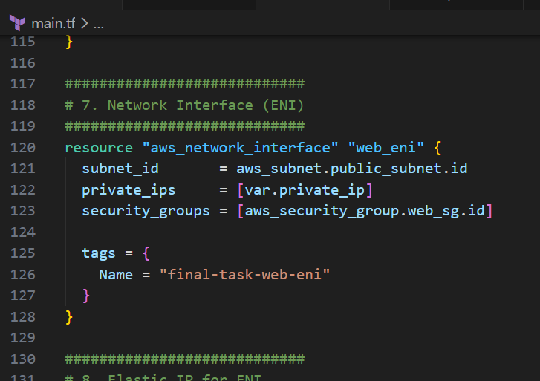

3️⃣ outputs.tf
output "elastic_ip" {
value = aws_eip.web_eip.public_ip
}

output "web_url" {
value = "http://${aws_eip.web_eip.public_ip}"
}

output "eni_id" {
value = aws_network_interface.web_eni.id
}

output "subnet_id" {
value = aws_subnet.public_subnet.id
}

output "vpc_id" {
value = aws_vpc.main_vpc.id
}
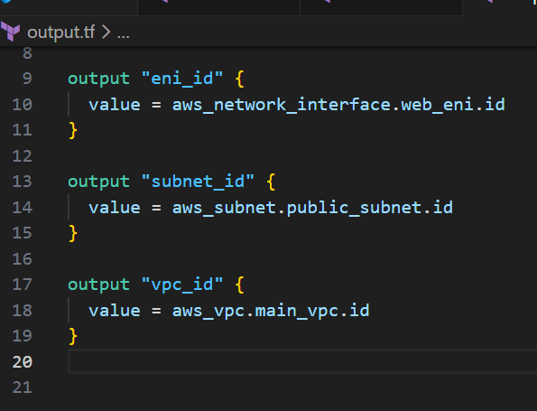
NOW open terminal
Terraform init
Terraform apply
All the service will be selected and created in aws.
